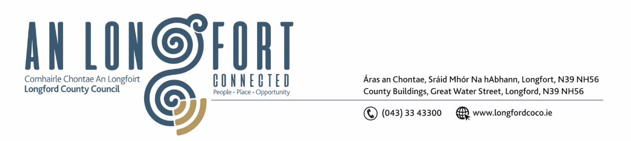

***LONGFORD MUNICIPAL DISTRICT***

***Please note meeting will be held in the Council Chamber, Aras an Chontae and via Microsoft Teams***

**20 July 2022.**

**To: Each Member of Longford Municipal District.**

**Dear Member,**

You are requested to attend the Meeting of Longford Municipal District to be held in **the Council Chamber, Aras an Chontae** and **via Microsoft Teams** on **Tuesday 26 July 2022 at 9.20am** to transact business, as set out on the agenda hereunder.

**Yours sincerely**,

Ann Marie Mc Keon

_______________

**Ann Marie Mc Keon**

**Meetings Administrator.**

**AGENDA**

Prayer before meeting.

**1.** Confirmation of Minutes:

1. Longford Municipal District Meeting held on Wednesday 22 June 2022 – copy enclosed.
2. Longford Municipal District Annual General Meeting held on Wednesday 22 June 2022 – copy enclosed.

**2.** Matters arising from Minutes.

**3.** Declaration of Interest by Members.

**4.** Management Report – to follow.

**5**. Sláintecare Healthy Communities presentation.

**6.** “Consideration of Adoption of Part 8, Number 95 in Accordance with Section 179 of the Planning and Development Act 2000 (as amended) and Part 8 of the Planning & Development Regulations 2001 (As Amended) – Proposeddevelopment will consist of the following: *(1)* Street and public realm improvement works along the N63 Ballinalee Road between the Junction of Ard Michael estate and the N63/N4 junction for a total distance of approximately 920m. The proposed works will include the provision of a cycle track and footpath contained within the existing verges on both sides of the N63, *(2)* Junction tightening works on both sides along the route, (3) Provision of a new controlled pedestrian and cycle crossing point, (4) The planting of native hedge screening and trees, provision of upgraded street lighting, road signage and markings, landscaping, and all ancillary site works along the N63 (Ballinalee Road), Longford Town.” – enclosed.

**7. Notices of Motions, submitted by Councillors, as listed hereunder –**

**Seamus Butler**

(i) That Longford Municipal District redesign the on street and council car park disabled parking bays to accommodate longer vehicles with wheelchair access at the rear. In addition, signage should be erected to warn of the penalty incurred for non-registered users at each bay.

(ii) That Longford Municipal District agree to extend the existing lighting at Ballymakeegan onto Lisduff Cross and up and down Lisduff Hill to Glebe. This will include a footpath to ensure the safety of residents on this very busy road.

**Councillor Martin Monaghan**

(i) I appreciate that our budget and schedule of works for footpaths and roads are pre- determined from last year, however Foynescourt paths are in very poor condition and there are a number of elderly residents and some of whom have mobility issues and require wheelchair use. With this in mind, if the management could find discretionary funding to carry out remedial works for the time being until such time as they are replaced it would be really appreciated.

(ii) There are no provisions for pedestrians to cross on the Ballinalee Road – There was a crossing from Ard Michael Estate to the Major’s Well Road prior to works commencing, however the provision of a temporary crossing to facilitate pedestrians would be a must to ensure the safety of the public when crossing such a major artery into our town.